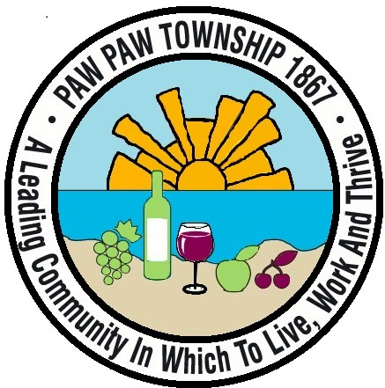 Paw Paw Senior Center Activities September 2024

Times: 8:30am-3pm

**Tuesday** **Wednesday** **Thursday**

**Events are Subject to Change…**

|  |  |  |
| --- | --- | --- |
| 3  8:30 am-12pm Pickleball 9amIndoor Walking 9am-2pm Mexican Train 9:30am Yoga  11am-3pm Yack & Yarnies 12pm-1pm Lunch  10am Chair Exercises  1pm-2pmBingo | 4  8:30 am-10:45am Pickleball 1:30pm Dancer-Cise  9am-2pm Indoor Walking **9am Chat w/Director**  9am-2pm Cards/ Mexican Train  11am-12pm Cardio Drumming  12pm-1pm Lunch | 5  8:30am-12pm Pickleball  9am-2pm Mexican Train 9:30am Yoga  9am-3pm Card/ Euchre/Bridge 12pm-1pm Lunch  9am-2pm Indoor Walking **1:30pm Hoopla Exercise**  11am-12pm Line Dancing |
| 10  8:30 am-12pm Pickleball 9amIndoor Walking 9am-2pm Mexican Train 9:30am Yoga  11am-3pm Yack & Yarnies 12pm-1pm Lunch  10am Chair Exercises1pm-2pmBingo | 11  8:30 am-10:45am Pickleball 1:30pm Dancer-Cise  9am-2pm Indoor Walking **9am Chat w/Director**  9am-2pm Cards/ Mexican Train  11am-12pm Cardio Drumming  12pm-1pm Lunch | 12  8:30am-12pm Pickleball  9am-2pm Mexican Train 9:30am Yoga  9am-3pm Card/ Euchre/Bridge 12pm-1pm Lunch 9am-2pm Indoor Walking 10am Chair Exercises11am-12pm Line Dancing **1:30pm Hoopla Exercise** |
| 17  **8:30 am-12pm Pickleball 9am Indoor Walking**  **9am- 2pm Cards/Mexican Train 9:30am Yoga**  **11am-3pm Yack & Yarnies 12pm-1pm Lunch**  **10am Chair Exercises**  **1pm-2pm Bingo**  **9am-12pm Commodities Entrance “A”** | 18  8:30 am-10:45am Pickleball **9am Chat w/Director**  9am-2pm Indoor Walking **9am AARP Phone Care**  9am-2pm Cards/ Mexican Train 10am Arts & Crafts $5.00  11am-12pm Cardio Drumming 12pm-1pm Lunch  1:30 pm Dancer-Cise **12:30pm Talk w/ Local Celebrity** | 19  8:30am-12pm Pickleball  9am-2pm Mexican Train 9:30am Yoga  9am-3pm Card/ Euchre/Bridge 12pm-1pm Lunch 9am-2pm Indoor Walking 10am Chair Exercises11am-12pm Line Dancing **1:30pm Hoopla Exercise** |
| 24  8:30 am-12pm Pickleball 9amIndoor Walking  9am- 2pm Cards/ Mexican Train 9:30am Yoga  11am-3pm Yack & Yarnies 12pm-1pm Lunch  10am Chair Exercises1pm-2pmBingo | 25  8:30 am-10:45am Pickleball **9am Chat w/Director**  9am-2pm Indoor Walking  9am-2pm Cards/ Mexican Train  11am-12pm Cardio Drumming 12pm-1pm Lunch  1:30 pm Dancer-Cise | 26  8:30am-12pm Pickleball  9am-2pm Mexican Train 9:30am Yoga  9am-3pm Card/ Euchre/Bridge 12pm-1pm Lunch 9am-2pm Indoor Walking 10am Chair Exercises  11am-12pm Line Dancing **1:30pm Hoopla Exercise** |
| **Senior Challenge:** you take as many of our exercise classes that we offer for the next three months, and you kept track of howtime you take those classes, and in December the ones who has the most classes will get something special… | **Special Event: Saturday September 7th at FW Church in the Gym, Pickleball Tournament at 9am. Come and support your favorite players. And see what we have in our silent auction and gift card pulls, this is a fund raiser for Paw Paw Senior Center so come out and support us.** | **Special Event: Saturday September 21st Bus Trip to Coldwater Apple Festival See Gary if interested, bus can only hold 23 people max... with fold up walkers. $20 fee. See the flyer for details. Fee is due when you sign-up!!**  **NOTE: Need Minimum 10 people to hold event** |