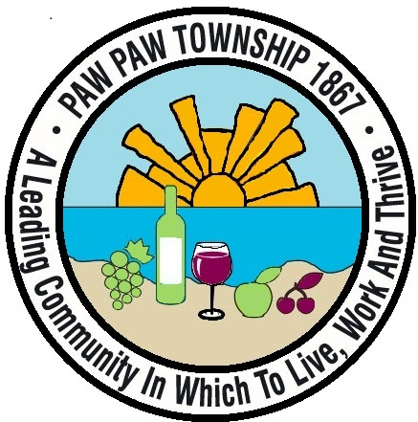 Paw Paw Senior Center, Located at Freshwater Church use Entrance ‘C’ Resident & Partners $6 Non-Resident $8 Time: 12-1pm

Lunch Menu **September 2024** Time: 12pm-1pm **Tuesday** **Wednesday** **Thursday**

**Note: Menu is subject to change**

|  |  |  |
| --- | --- | --- |
| 3  Fish Sandwich, w/French Fries & Cole Slaw, or Cobb Dinner Salad | 4  Ham Au Gratin Potatoes w/Peas & Roll or Chef Dinner Salad | 5  Meatloaf, Mashed Potatoes & Green Beans, & Roll or Chicken Dinner Salad |
| 10  Autumn Chowder w/ Chicken Salad Croissants or Cobb Dinner Salad | 11  S & S Chicken w/ Rice & Carrots or Chef Dinner Salad | 12  Italian Chicken w/ Rice Pilaf & Veggies & Roll or SW Chicken Dinner Salad |
| 17  Wet Burrito w/ Rice & Beans or Cobb Dinner Salad | 18  Ham & Green Beans & Potatoes w/Corn Bread or Chef Dinner Salad | 19  Grand Slam w/Soup & Fruit or S.W. Chicken Dinner Salad |
| 24  Country Fried Steak w/Cheesy Potatoes & Veggies & Roll or Cobb Dinner Salad | 25  Goulash w/Cole Slaw & Garlic Bread or Chef Dinner Salad | 26  Chicken Pot Pie w/Mashed Potatoes & Fruit or Chicken Apple Dinner Salad |
|  |  |  |